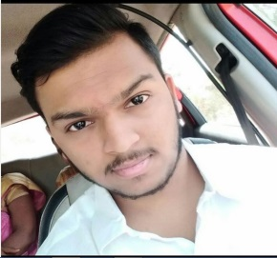

NAME – SAURABH SUDAM TAMHANE ( सौरभ सुदाम ताम्हाणे )
BORN – 18 APRIL 2000 AGE – LANGUAGE - MARATHI , HINDHI
WHATSAPP NO – 8788464862
EMAIL – saurabhtamhane12@gmail.com
EDUCATION – 12th PASS MAHARASTRA BOARD
LIVE – GHANSOLI NAVI MUMBAI PIN CODE – 400701
PROFILE - https://www.facebook.com/ImSaurabhSTamhane
WEBSITE - https://saurabhtamhane.wixsite.com/saurabhstamhanefilms
PRODUCTION – Saurabh S. Tamhane Films
WORK EXPERIENCE - ACTING , DIRECTION , SCRIPT WRITING
ACTING
SHORTFILM , WEBSERIES AND TELEFILMS
- JANIV https://www.youtube.com/watch?v=g5Up-GwlT44&t=4s
- KAY RE PRODUSRA https://www.youtube.com/watch?v=9-Rij0eGnj0&t=1s
DIRECTION / ASST. DIRECTOR
SHORTFILM , WEBSERIES AND TELEFILMS
- JANIV https://www.youtube.com/watch?v=g5Up-GwlT44&t=4s
- LIMBHU MIRCHI https://www.youtube.com/watch?v=tqRVfI7msLU&t=68s
- CORPORATE RISKS https://www.youtube.com/watch?v=b-Em3khZLXA&t=4s
- BALATKAR - COMING FOR YOUTUBE
- VIKRUTI https://www.youtube.com/watch?v=b4UFaY17X-E&t=83s

